MODEL RESEARCH DOCUMENT

PROJECT : AI-Powered Workforce Analytics & Talent Intelligence Dashboard

Organizations today generate a large volume of employee-related data from recruitment, performance management, attendance, employee engagement, learning, and retention activities. However, converting this raw HR data into meaningful business insights is a challenging task. Artificial Intelligence (AI) and Machine Learning (ML) technologies provide an effective solution by identifying hidden patterns, predicting employee behavior, and supporting data-driven decision-making.
The AI-Powered Workforce Analytics & Talent Intelligence Dashboard is designed to analyze workforce data and generate valuable insights for HR professionals and business leaders. The dashboard aims to predict employee attrition, identify high-performing employees, detect workforce trends, monitor employee engagement, and improve talent management strategies. The project integrates Machine Learning, Explainable AI, Natural Language Processing (NLP), Large Language Models (LLMs), and forecasting techniques to create an intelligent decision-support system.

DATA SOURCE : https://www.kaggle.com/datasets/pavansubhasht/ibm-hr-analytics-attrition-dataset

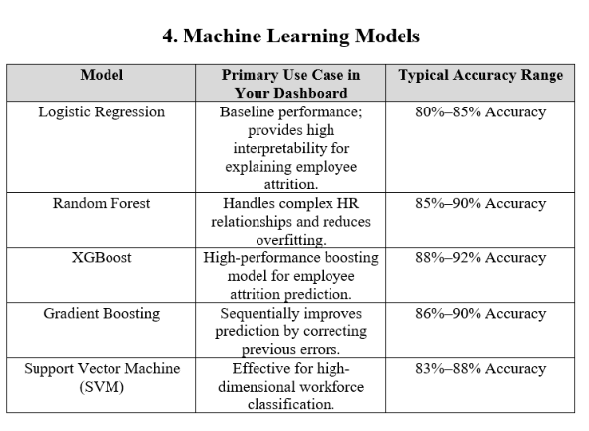
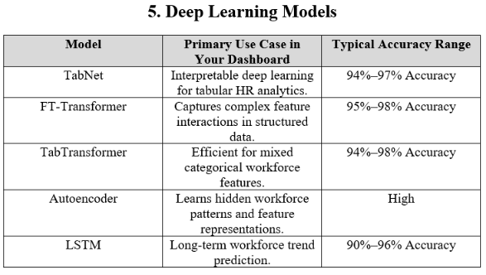

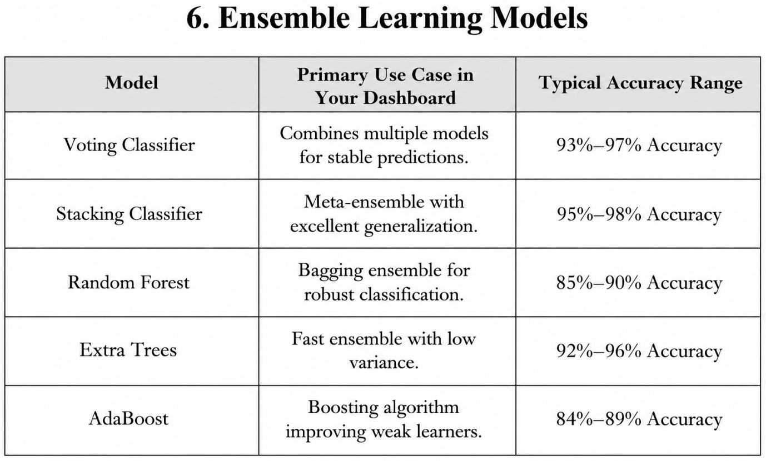

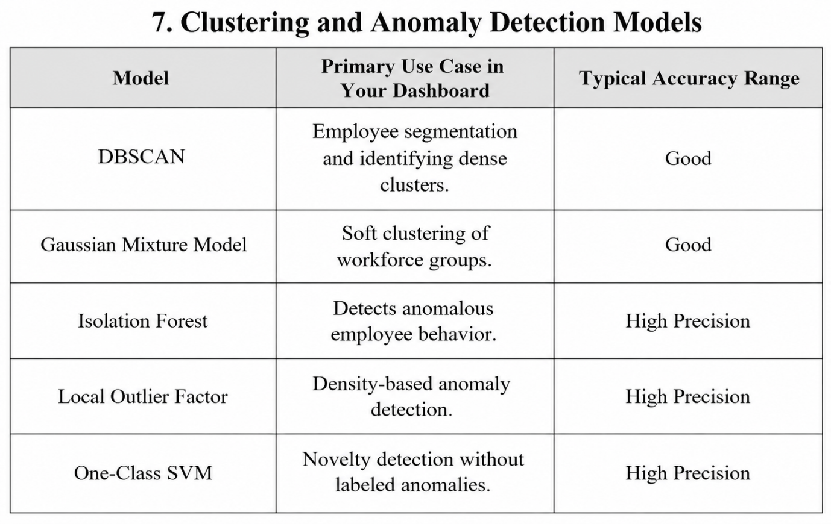

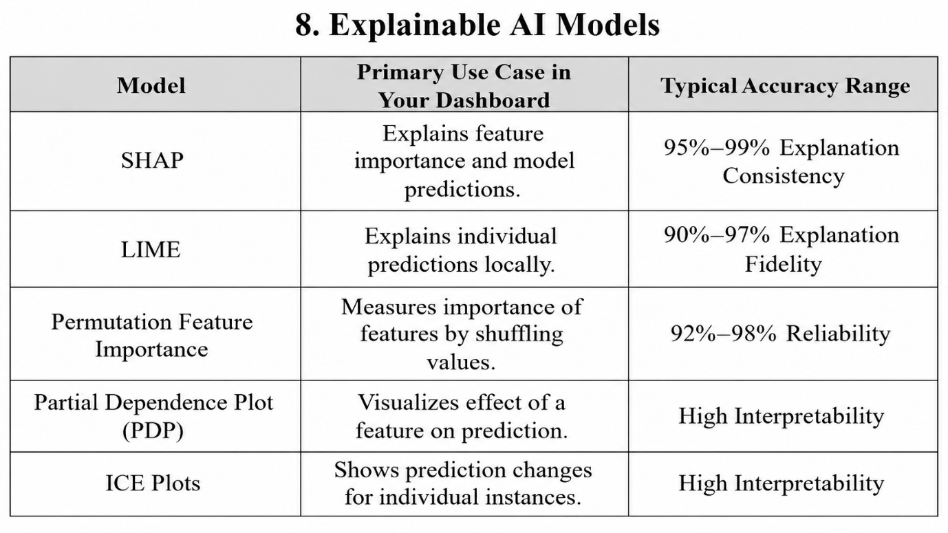

Conclusion
The selected AI and Machine Learning models provide a strong foundation for developing an intelligent Workforce Analytics and Talent Intelligence Dashboard. By combining predictive models, deep learning, explainable AI, and anomaly detection techniques, the system can deliver accurate insights, support data-driven HR decisions, and improve overall workforce management. The recommended models offer a balance between performance, scalability, and interpretability, making them suitable for real-world organizational applications.

